**Annexure-1**

Letter Ref: No:

From Date:

To

# Subject: Constitution of Institution Ethics Committee (Human studies)

Dear Sir/Madam

On behalf of Indira Gandhi Medical College Shimla, I request your concurrence for induction as a Member/Member Secretary/Chairman of Institutional Ethics Committee of this institute. Kindly send your written acceptance in the enclosed format and provide the necessary information requested.

Your Sincerely, Signature: Name:

# Annexure-2

From

………………

……………… To

………………

………………

Subject: Consent to be a Member /Member Secretary /Chairman of Institutional Ethics Committee (Human studies)

Dear Sir/Madam

In response to your letter stated above, I give my consent to become a member/member secretary /chairman of IEC of IGMC Shimla. I shall regularly participate in the IEC meeting to review and give my unbiased opinion regarding the ethical issues. I shall be willing for my name, profession and affiliation to be published I shall not keep any literature or study related document with me after the discussion and final review.

I shall maintain all the research project related information confidential and shall not reveal the same to anyone other than project related personnel.

I here with enclose my C.V. Thanking you,

Your Sincerely,

Signature…………………….

Name of the Member Date:

Address: Telephone No: Off: Res:

Email:

# Annexure-3

**Format for according approval to the clinical trial protocols by the Ethics Committee**

To Dr.

Dear Dr.

The Institutional Ethics Committee reviewed and discussed your application to conduct the clinical trial entitled “…………” on date

The following documents were reviewed:

1. Trial protocol (including protocol amendments), date version no
2. Patient Information Sheet and Informed Consent Form (including updated if any) in English and/or vernacular language.
3. Investigator’s Brochure, dated version no.
4. Proposed methods for the patient accrual including advertisement(s) etc. proposed to be used for the purpose.
5. Principal Investigator’s current CV.
6. Insurance Policy/Compensation for participation and for serious adverse events occurring during the study participation.
7. Investigator’s Agreement with the Sponsor.
8. Investigator’s Undertaking
9. List of other documents attached as a Annexture

The following members of the ethics committee were present at the meeting held on (date, time, place)

Chairman of the Ethics Committee

Member secretary of the Ethics Committee

Name of each member with designation

Approved in its present form/Revision with minor modifications and approval after re-examination by member secretary or expedited review sub-committee/Revision with major modifications for resubmission- to be placed before full IEC for reconsideration/Not approved- with clear reasons for non-approval.

The approval is subject to quarterly/ half yearly/annual review of the study. The Institutional Ethics Committee is to be informed about any serious adverse events occurring in the course of the study, any changes in the protocol and patient information sheet/informed consent form.

This approval is valid for 01 year from the date of issuance pf this certificate: DD/MM/YYYY.

To get a re-approval, kindly submit the annual progress report of the study along with request letter for re-approval. Approval mandates timely submission of study completion report on or before DD/MM/YYYY.

Yours sincerely

Member Secretary,

Ethics Committee.

# Annexure-4: Form IA

**Recommendation of Thesis Protocol Review Committee (PRC)/Research Proposals to be submitted to Institute Ethical Committee, IGMC Shimla.**

1. Title of the Project:
2. Name of the Department:
3. Name of the candidate:
4. Name of Guide:
5. Whether the Aims and Objectives of the proposed study clearly defined? Yes/No
6. Is the need of study/Novelty of the study highlighted? Yes/No
7. Is review of literature adequate to identify the existing knowledge and

gaps to justify the study? Yes/No

1. Is the study design appropriate for answering the research question? Yes/No
2. Is the patient/study population clearly defined? Yes/No
3. Is the sampling methodology / selection of patients clearly defined? Yes/No
4. Is the sample size appropriately calculated? Yes/No
5. Whether the data collection methods adequately described? Yes/No
6. Whether the data measurement tools proposed to be used are validated? Yes/No
7. Does data analysis describe how the data would be analyzed to

answer the research objectives? Yes/No

1. If answers to any of the above checklist is No, make your comments and suggestions to be incorporated by candidate:

a.

b.

c.

d.

18. Final recommendation of the committee to Ethical Committee:

a. The scientific quality of the protocol: Not satisfactory / Satisfactory

b. Ethical components of the research protocol:

I. Potential anticipated risk of harm to the subjects: Minimal / Small / Major/Catastrophic

II. Provisions mentioned in methodology for the potential harms anticipated to the subject: Yes / No

III. Anticipated benefits from research: Not certain / Likely to be Yes / No

IV. Is the methods of selection of subjects equitable? Yes / No

V. Is research information provided in the patient information document adequate to ensure self-respect, dignity and freedom to take decision for participation in the research? Yes/No

Approved for submission to ethical committee / Needs resubmission after incorporation of suggestion made / Rejected.

Member, PRC Chairman, PRC

Signature with stamp

Dated

**Annexure-5: Form IB (submitted in typed format only)**

**Performa to be submitted to the Ethics Committee (Human studies) (for MD/MS/DM/MCH**

**/PhD (for Thesis or Dissertation/MBBS student projects)**

*Kindly submit 01 copy of proforma and consent forms in English & Hindi to the Member Secretary, Institute Ethics Committee (Human Studies), IGMC Shimla*

1. Title of the project:
2. Name and Department/address of the investigators:
3. Number of Faculty (Guide/Co-guide) with designation & department:
4. Date of approval by Institute Research Council/Scientific Advisory/Thesis protocols crutiny committee.
5. Sources of funding
6. Objectives of the study:
7. Justification for the conduct of the study:
8. Methodology: It should provide details of number of patients, inclusion criteria, exclusion criteria, control(s), study design, dosages of drug duration of treatment, investigations to be done etc:
9. Permission from Drug Controller General of India (DCGI) if applicable
10. Ethical issues involved in the study:

*No risk/ less than minimal risk/ more than minimal risk to the study subjects (for guidance please consult ICMR guidelines2017).*

1. Do you need exemption from obtaining Informed Consent from study subjects- if so give justifications?
2. Whether Consent forms part 1 and2 in English and in local language are enclosed?
3. Conflict of interest for any other investigator(s)(if yes, please explain in brief)
4. We, the undersigned, have read and understood this protocol and hereby agree to conduct the study in accordance with this protocol and to comply with all requirement of the ICMR guidelines (2017)

Signature of the Investigators:

Contact:

E Mail Id:

Signature of the Head of the Department

(**Note**: The proforma must be accompanied by consent forms I & II in English and Hindi Consent form I is equivalent to patient Information Sheet. The investigators must provide information to the subjects in a simple language, and it should address the subjects, in a dialogue format

**Annexure-6: Form II**

**Contents of the proposed protocol for conducting clinical trials**

# Title Page

1. Full title of the clinical study.
2. Protocol/Study number, and protocol version number with date
3. The IND name/number of the investigational drug
4. Compete name and address of the Sponsor and contract research organization if any
5. List of the Investigators who are conducting the study, their respective institutional affiliations and site locations
6. Name(s) of clinical laboratories and other departments and/or facilities participating in the study.

# Table of Contents

A complete Table of Contents including list of all Appendices.

1. Background and Introduction
   1. Preclinical experience
   2. Clinical experience

Previous clinical work with the new drug should be reviewed here and a description of how the current protocol extends existing date should be provided. If this is an entirely new indication, how this drug was considered for this should be discussed. Relevant information regarding pharmacological, toxicological and other biological properties of the drug/biologic/medical device, and previous efficacy and safety experience should be described.

1. Study Rationale

This section should describe a brief summary of the background information relevant to the study design and protocol methodology. The reason for performing this study in the particular included by the protocol should be provided.

1. A Study Objective(s)(primary as well as secondary)and their logical relations to the study design.

# Study Design

1. Overview of the study Design: Including a description of the type study(i.e. Double-blind, multi-center, placebo controlled, etc.),a detail of the specific treatment groups and number of study Subject in each group and investigative site, Subject number assignment, and the type, sequence and duration of study periods.
2. Flowchart of the study
3. A brief description of the methods and procedures to be used during the study.
4. Discussion of Study design: This discussion details the rationale for the design chosen for this study.
5. Study Population: the number of Subjects required to be enrolled in the study at the Investigative site and by all sites along with a brief description of the nature of the Subject population required is also mentioned.
6. Subject Eligibility
7. Inclusion Criteria
8. Exclusion Criteria
9. Study Assessments –plan procedures and methods to be described in detail
10. Study Conduct stating the types of study activities that would be included in this section would be: medical history, type of physical examination, blood or urine testing electrocardiogram (ECG), diagnostic testing such as pulmonary function tests, symptom measurement, dispensation and retrieval of medication, Subject cohort assignment, adverse event review etc.

Each visit should be described separately as visit I, Visit 2, etc.

Discontinued Subjects: Describes the circumstances for subject withdrawal, dropouts, or other reasons for discontinuation of subjects. State how dropouts would be managed if they would be replaced

Describe the method of handling of protocol waivers, if any. The person(s) who approves all such waivers should be identified and the criteria used for specific waivers should be provided.

Describe how protocol violations will be treated, including conditions where the study will be terminated for non-compliance with the protocol.

1. Study treatment
2. Dosing schedule (dose, frequency, and duration of the experimental treatment) Describe

the administration of placebos and/or dummy medications if they are part of the treatment plan. If applicable, concomitant drugs(s), their doses, frequency and duration of concomitant should be stated.

1. Study drug supplies and administration: A statement about who is going to provide the study medication and that the investigational drug formulation has been manufactured following all regulations, details of the product stability, storage requirement and dispensing requirement should be provided.
2. Dose modification for study drug toxicity: rules for changing the dose or stopping the study drug should be provided
3. Possible drug interactions
4. Concomitant therapy: the drugs that are permitted during the study and conditions under which they may be used are detailed here. Describes rugs that are not allowed to use during parts of or the entire study. If any washout period for prohibited medication are needed prior to enrolment, these should be described here.
5. Blinding procedures: A detailed description of the blinding procedure if the study employs a blind on the investigator and / or the subject
6. Unbinding procedures: If the study is blinded, the circumstances in which unbinding may be done and the mechanism to be used for unblinding should be given
7. Adverse Events Description of expected adverse events should be given.
8. Ethical Considerations: Give the Summary of:
9. Risk/benefit assessment:
10. Ethics Committee review and communications
11. Informed consent process
12. Statement of subject confidentially including ownership of date coding procedures
13. Study Monitoring and Supervision: a description of study monitoring policies and procedures should be provided along with the proposed frequency of site monitoring visits, and who is expected to perform monitoring

Case Record (CRF) completion requirements, including who gets which copies of the forms and any specifics required in filling out the forms CRF corrections requirements, including who is authorized to make corrections on the CRF and how queries about study data are handled and how errors, if any, are to be corrected should be stated.

Investigator study files, including what needs to be stored following study completion should be described.

1. Investigational Product Management
2. Give Investigational product description and packaging (stating all ingredients and the formulations of the investigational drug and any placebos used in the study)
3. The precise dosing required during the study.
4. Method of assigning treatments to subjects and the Subject identification code numbering system.
5. Method of assigning treatments to subjects and the subject identification code numbering system.
6. Storage conditions for study substances
7. Investigational product accountability: Describe instructions for the receipt, storage, dispensation, and return of the investigational products to ensure complete accounting of all investigational products received, dispensed, and returned /destroyed.
8. Describe policy and procedure for handling unused investigational products.
9. Data Analysis:

Provide details of the statistical approach to be followed including sample size, how the sample was determined, including assumptions made in making this determination, efficacy endpoints (primary as well as secondary) and safety endpoints.

Statistical analysis: Give complete details of how the results will be analyzed and reported along with the description of statistical tests to be used to analyze the primary and secondary endpoints defined above. Describe the level of significance, statistical tests to be used and the methods used for missing data: method of evaluation of data for treatment failures, non- compliance, and Subject withdrawals: rationale and conditions for any interim analysis if planned.

Describe statistical considerations for Pharmacokinetic (PK) analysis, if applicable

1. Undertaking by the investigators
2. Appendices: Provide a study synopsis, copies of the informed consent documents (patients

Information sheet, informed consent form etc.): CRF and other data collection forms; a summary of relevant pre-clinical safety information and any other documents in the clinical protocol.

**Annexure-7: FORM III**

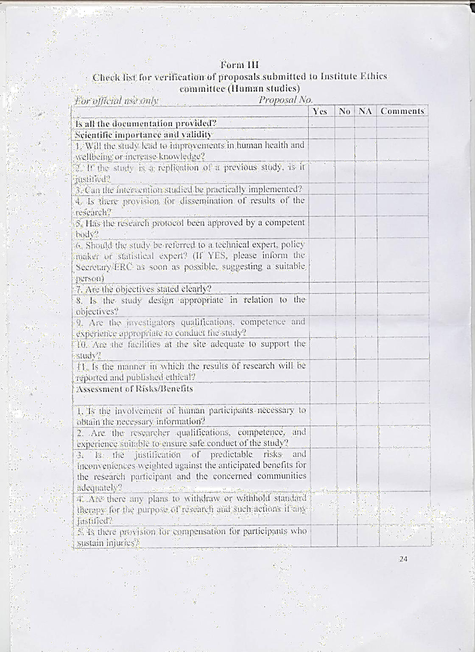

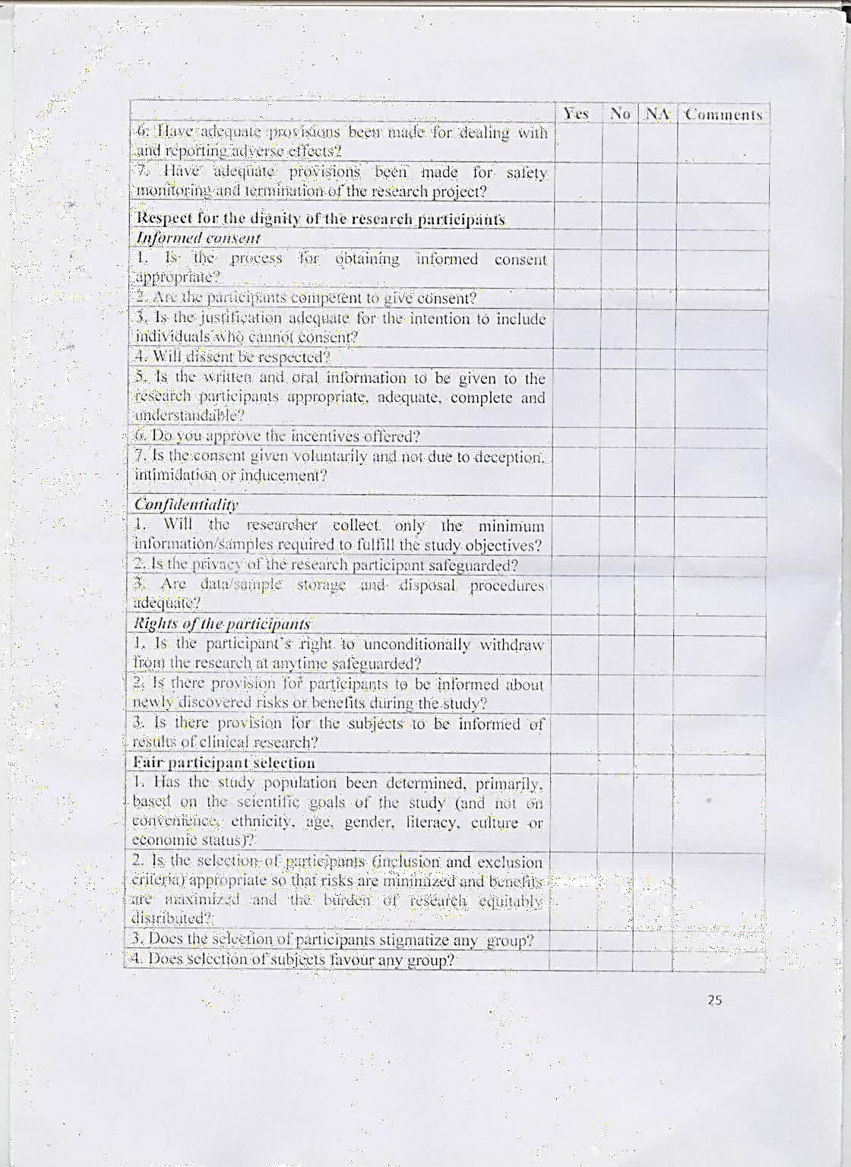

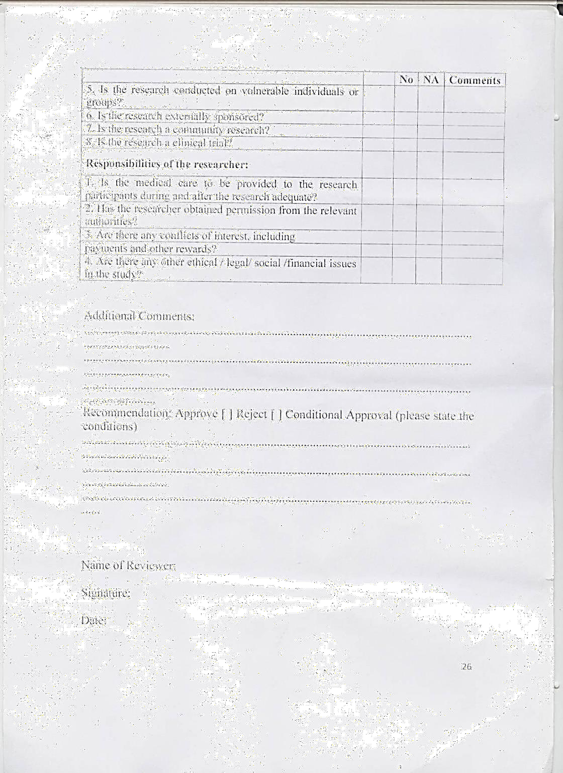

**Annexure-8: FORM-IV (A)**

1. **CHECK LIST FOR STUDY SUBJECT’S INFORMED CONSENT DOCUMENTS**
   1. Essential Element:
      1. Statement that the study involves research and explanation of the purpose of the research
      2. Expected duration of the Subject’s participation
      3. Description of the procedures to be followed, including all procedures and
      4. Description of any reasonably for seeable risks or discomforts to the subject
      5. Description of any benefits to the subject or others reasonably expected from research. If no benefit is expected subject should be made aware of this.
      6. Disclosure of specific appropriate alternative procedures or therapies available to the subject.
      7. Statement describing the extent to which confidentially of records identifying the subject will be maintained and who will have access to subject’s medical records
      8. Trial treatment schedule(s) and the probability for random assignment to each treatment (for randomized trials)
      9. Compensation and/or treatment(s) available to the subject in the event of trial-related injury
      10. An explanation about whom to contact for trial related queries, rights of subjects and in the event of any injury.
      11. The anticipated prorated payment, if any, to the subject for participating in the trial
      12. Subject’s responsibilities on participation in the trial.
      13. Statement that participation is voluntary, that the subject can withdraw from the study at any time and that refusal to participate will not involve any penalty or loss of benefits to which the subject is otherwise entitled
      14. Statement that there is a possibility of failure of investigational product to provide intended therapeutic effect.
      15. Statement that in the case of placebo-controlled trial, the placebo administered to the subjects shall not have any therapeutic effect.
      16. Any other pertinent information

# Additional elements, which may be required

1. Statement of foreseeable circumstances under which the subject’s participation may be terminated by the Investigator without the subject’s consent.
2. Additional costs to the subject that may result from participation in the study.
3. The consequences of a subject’s decision to withdraw from the research and procedures for orderly termination of participation by subject.
4. Statement that the subject or subject’s representative will be notified in a timely manner if significant new finding develops during the course of the research which may affect the subject’s willingness to continue participation will be provided.
5. A statement that the particular treatment or procedure may involve risks to the subject (or to the embryo or fetus, if the subject is or may become pregnant), which are currently unforeseeable
6. Approximate number of subjects enrolled in the study

# Annexure-9: Form IV(B)

**FORMAT OF INFORMED CONSENT FORM FOR SUBJECTS PARTICIPATING IN A CLINICAL TRIAL**

Informed Consent form to participate in a clinical trial

|  |  |  |  |  |
| --- | --- | --- | --- | --- |
| Study Title: | | | | |
| Study Number: | | | | |
| Subject’s Initials | | Subject’s Name |  |  |
| Date of birth/Age: Address of Subject  Qualification  Occupation: Student or Self-Employed or Service or Housewife or Others (Please click as appropriate) .  Annual Income of the subject:  Name and address of the nominees and his/her relation to the subject (for the purpose of compensation in case of trial related death).  Please initial Box (Subject) | | | | |
| (i) | I confirm that I have read and understood the information sheet dated | | [ | ] |
| For the above study and have had the opportunity | | | | |
|  | to ask question. |  |  |  |
| (ii) | I understood that my participation in the study is voluntary and that I am | | [ | ] |
| Free to withdraw at any time ‘without giving any reason. | | | | |
| Without my medical care or legal rights being affected. | | | | |
| (iii) | I understand that the spoons or of the clinical trial, others working on the  sponsor | | [ | ] |
|  | ’sbehalf’theEthicsCommitteeandtheregulatoryauthoritieswillnotneed  my | |  |  |
|  | Permission to look at my health records both in respect of the current study  and | |  |  |
|  | Any further research that may be conducted in relation to it, even if I  withdraw | |  |  |

|  |  |  |  |
| --- | --- | --- | --- |
| From the trial. I agree to this access. However, I understand that my identity | | | |
| Will not be revealed in any information on released to third parties or published. | | | |
| (iv) | I agree not to restrict the use of any data or result that arise from this study | [ | ] |
|  | Provided such a use only for scientific purpose(s) |  |  |

1. I agree to take part in the above study.

Signature (or Thumb impression of the subject/legally acceptable Representative:

Date / /

Signatory’s Name:

Signature of the Investigator:

Study Investigator’s Name:

Signature of the Witness Date: / /

Signature of the Witness Date / /

Copy of the Patient Information Sheet and duly filled Informed Consent Form shall be handed over to the subject his or her attendant.

**Annexure-09 A FORM IV(C)**

**PARTICIPANT INFORMATION SHEET (PIS)**

STUDY TITLE:

PROTOCOL NO:

SPONSOR:

PRINCIPAL INVESTIGATOR:

Name of Participant:

1. You are invited to take part in this research study. The information in this document is meant to help you decide whether or not to take part. Please feel free to ask if you have any queries or concerns.

2. What is your expected duration of the participation?

3. What procedures will be followed during this study?

4. What are the risks and discomforts to you?

5. What benefits are expected from this research?

6. What are the alternatives available to you?

7. Are the data/records of the participant kept confidential?

8. What will be the treatment schedule(s)?

9. What compensation and/or treatment(s) are available to the Participant in the event of a trial-related injury?

10. Whom to contact for trial related queries and what are the rights of Participant’s in the event of any injury?

11. Are the participants paid to take part in this study?

12. What are your responsibilities during participation in the study?

13. Statement that participation is voluntary, that the Participant can withdraw from thestudy at any time and that refusal to participate will not involve any penalty or loss of benefits to which the Participant is otherwise entitled.

**Participant or Participant's representative will be notified in a timely manner if**

1. Significant new findings develop during the course of the research which may affect the Participant's willingness to continue participation will be provided.

2. Statement of foreseeable circumstances under which the Participant's participation

may be terminated by the Investigator without the Participant's consent.

3. Additional costs to the Participant that may result from participation in the study.

4. The consequences of a Participant's decision to withdraw from the research and procedures for orderly termination of participation by Participant.

5. A statement that the particular treatment or procedure may involve risks to the Participant (or to the embryo or fetus, if the Participant is or may become pregnant), which are currently unforeseeable

6. Approximate number of Participants enrolled in the study:

7. Any other pertinent information

Contact persons:

For further information, / questions, you can contact:

Principal Investigator:

You are also free to contact: The Head of Department of……………,

In case of conflicts, you can contact Institutional Ethics Committee at the following address:

The, Institutional Ethics Committee, IGMC Shimla

**Annexure-10: FORM V**

**UNDERTAKING BY THE INVESTIGATOR**

* 1. Full name, address and title of the Principal Investigator (or Investigator(s) when there is no Principal Investigator)
  2. Name and address of the medical college, hospital or other facility where the clinical trial will be conducted: Education, training & experience that qualify the Investigator for the clinical trial (Attach details including Medical Council registration number, and /or other statement(s) of qualification(s)
  3. Name and address of all clinical laboratory facilities to be used in the study.
  4. Name and address of the Ethics Committee that is responsible for approval and continuing review of the study.
  5. Names of the other members of the research team (Co-or sub-Investigators) who will be assisting the Investigator in the conduct of the investigation (s).
  6. Protocol Title and study number (if any) of the clinical trial to be conducted by the Investigator.
  7. Commitments:
     1. I have reviewed the clinical protocol and agree that it contains all the necessary information to conduct the study. I will not begin the study until all necessary Ethics Committee and regulatory approvals have been obtained.
     2. I agree to conduct the study in accordance with the current protocol. I will not implement any deviation from or changes of the protocol without agreement by the sponsor and prior review and documented approval / favorable opinion from the Ethics Committee of the amendment, expect where necessary to eliminate an immediate hazard(s) to the trial subjects or when the changes(s) involved are only logistical or administrative in nature.
     3. I agree to personally conduct and/or supervise the clinical trial at my site.
     4. I agree to inform all trial subject, that the drugs are being used for investigational purposes and I will ensure that the requirements relating to obtaining informed consent and ethics committee review and approval specified in the New Drugs and Clinical Trials Rules, 2019 and Good Clinical Practices guidelines are met.
     5. I agree to report to the sponsor all adverse experiences that occur in the course of the investigation(s) in accordance with the regulatory and GCP guidelines.
     6. I have read and understood the information in the Investigator’ brochure, including the potential risks and side effects of the drug.
     7. I agree to ensure that all associates, colleagues and employees assisting in the conduct of the study are suitably qualified and experienced and they have been informed about obligations in meeting their commitments in the trial.
     8. I agree to maintain adequate and accurate records and to make those records available for audit/inspection by the sponsor, Ethics Committee, Licensing Authority or their authorized representative, in accordance with regulatory and GCP provisions. I will fully cooperate

with any study related audit conducted by regulatory officials or authorized representatives of the sponsor.

* + 1. I agree to promptly report to the Ethics Committee all changes in the clinical trial activities and all unanticipated problems involving risk to human subjects or others.
    2. I agree to inform all serious adverse events to the Central Licensing Authority, sponsor as well as the ethics committee within twenty-four hours of their occurrence. In case, of failure to do so, I shall furnish the reason for the delay to the satisfaction of the Central Licensing Authority along with the report of the serious adverse event.
    3. The report of the serious adverse event, after due analysis, shall also be forwarded by me to the Central Licensing Authority, the Chairperson of the ethics committee and the Head of the institution where the trial has been conducted within fourteen days in accordance with the regulatory requirements.
    4. I will maintain confidentially of the identification of all participating study patients and assure security and confidentially of study data.
    5. I agree to comply with all other requirement, guidelines and statutory obligations as applicable to clinical Investigator participating in clinical trials.

Signature of Investigator with date

**Annexure-11: Form VI**

**DATA ELEMENTS FOR REPORTING SERIOUS ADVERSE EVENTS OCCURRING IN A CLINICAL TRIAL OR BIOAVAILABILITY OR BIOEQUIVALENCE STUDY**

* + 1. Patient Details:

Initials and other relevant identifier (hospital or out-patient department (OPD) record number etc.) *

* Gender
* Age or date of birth Weight
* Height

1. Suspected Drug(s):
   * Generic name of the drug*
   * Indication(s) for which suspect drug was prescribed or tested. Dosage form and strength.
   * Daily dose and regimen (specify units-e.g., mg, ml, mg/kg). Route of administration.
   * Starting date and time of day.
   * Stopping date and time, or duration of treatment
2. Other Treatment(s):

* Provide the same information for concomitant drugs (including non-prescription or Over the Counter OTC drugs) and non-drug therapies, as for the suspected drug(s).

1. Details of Serious Adverse Event:

Full description of the event including body site and severity, as well as the criterion (or criteria) for considering the report as serious. In addition to a description of the reported signs and symptoms, whenever possible, describe

* specific diagnosis for the event*
* Start date (& time) of onset of event.
* Stop date (and time) or duration of event. De challenge and rechallenge information.
* Setting (e.g. Hospital, out-patient clinic, home, nursing home).

1. Outcome

* Information on recovery and any sequelae; results of specific test so retreatment that may have been conducted.
* For a fatal outcome, cause of death and a comment on its possible relationship to the suspected event; Any post-mortem findings.

*Other information:* anything relevant to facilitate assessment of the case, such as medical history including allergy, drug or alcohol abuse; family history; findings from special investigations etc.

1. Details about the Investigator*
   * Name and Address
   * Telephone number
   * Profession (specialty)
   * Date of reporting the event to Central Licensing Authority:
   * Date of reporting the event to ethics committee overseeing the site: Signature of the Investigator or Sponsor

**Note:** Information marked *must be provided

**Annexure-12. Format for submission of Annual Progress Report of Clinical Trials for investigators**

1. **Principal Investigator details**

Name Designation Department Email ID Contact number

# Study details-

* 1. Title
  2. IEC Number
  3. IEC Approval date
  4. Sponsor/Grant agency
  5. CTRI number (in case of Clinical Trial):

If not registered, give reason f. Date of start of study

(if not started, give reason and expected start date)

* 1. Date of last status report (if submitted)

1. **Summary of work done (**along with preliminary findings and publications from research if any)
   1. Till date
   2. Within last one year

# Serious Adverse Events (SAEs)/any unexpected adverse event

Were all SAEs/unexpected adverse events reported to IEC If yes, reference number and dates

(info, give reason)

Whether reports of SAE sat other sites have been submitted to the IEC IGMC Shimla

# Protocol amendments within last one year (if any)

Were the amendments approved by the IEC (if no, give reason)

# Protocol violations within last one year

Any major protocol violations (if any)

If yes, were they reported to IEC (reference number and dates) (if no, give reason)

# New information

Any new information that can alter the risk/benefit assessment (If yes, give details)

# Other issues within the last 1 year

Any issues that PI wishes to report to IEC (change of Co-I, addition/deletion of sites, etc.) If yes, give details

1. **Signature of PI with date**

**Annexure-12A. Format for submission of Annual Progress Report of Research Proposals for investigators**

**PART 1: GENERAL INFORMATION**

1. Project Title:
2. a. Broad Area:

Basic/Translational/ Clinical/ Systems research/ Community/ Education/ Behavioral

b. Specific Area:

3. Project Started on:

4. Duration:

5. Funding Agency:

6. Funds:

a. Sanctioned:

b. Utilized so far:

6. Investigators:

a. Principal Investigator:

b. Co- Investigator (s):

**PART II: TECHNICAL REPORT**

7. Specific objectives:

8. Work done so far (objective wise):

9. Timelines (Achieved):

|  |  |
| --- | --- |
| Milestones | Targets Achieved |
|  |  |
|  |  |

1. Detailed results:

1. Discussion:
2. Conclusion:
3. Implications/ Outcomes:
4. Summary of the results (250 words):

1. Publications out of the project work:
2. Signature of PI:

# Annexure-13: Format for submission of Study Completion reports of Clinical Trials for Investigators

1. **Principal Investigator details**

Name Designation Department Email ID Contact number

# Study details-

* 1. Title
  2. IEC Number
  3. IEC Approval date
  4. Sponsor/Grant agency
  5. CTRI number(in case of Clinical Trial):

If not registered, give reason

* 1. Date of start of study
  2. Date of completion of Study

1. **Summary of work done (**along with results of the study and publications from the study, if any)

# Serious Adverse Events(SAEs)/any unexpected adverse event

Were all SAEs/unexpected adverse event reported to IEC If yes, reference number and dates

(info, give reason)

Whether reports of SAE sat other sites have been submitted to the IEC IGMC Shimla

# Protocol amendments (if any)

Were these amendments approved by the IEC (if no, give reason).

# Protocol violations

Any major protocol violations (if any)

If yes, were they reported to IEC (if no, give reason)

1. **Annual Reports submitted regarding the study** (reference no. and dates)
2. **Signature of PI with date**

# Annexure-13A: Format for submission of Study Completion reports of Research Proposals for Investigators

**PART 1: GENERAL INFORMATION**

1. Project Title:
2. a. Broad Area:

Basic/Translational/ Clinical/ Systems research/ Community/ Education/ Behavioral

b. Specific Area:

3. Project Started on:

4. Duration:

5. Funding Agency:

6. Funds:

a. Sanctioned:

b. Utilized so far:

6. Investigators:

a. Principal Investigator:

b. Co- Investigator (s):

**PART II: TECHNICAL REPORT**

7. Specific objectives:

8. Work done so far (objective wise):

9. Timelines (Achieved):

|  |  |
| --- | --- |
| Milestones | Targets Achieved |
|  |  |
|  |  |

1. Detailed results:

1. Discussion:
2. Conclusion:
3. Implications/ Outcomes:
4. Summary of the results (250 words):

1. Publications out of the project work:
2. Annual Reports submitted regarding the study (reference no. & date)
3. Signature of PI with Date:

**Annexure-14**

**Format for resubmission of revised protocols/submission of additional documents for Investigators**

**DATE OF RESUBMISSION:**

# Principal Investigator (PI); MD/MS/DM/MCH/ PhD candidate details

# Name Designation

# Department

# Email ID

# Contact number

# Study details

Title:

1. **Purpose of this submission (**e.g. Revised Informed Consent/Assent document; Participant Information Sheet; Change in Protocol, Addition/Deletion in Protocol etc.):

# Submission details

|  |  |  |  |
| --- | --- | --- | --- |
| Sr. No. | Revision/Corrections Suggested by IEC | Corrections done: Yes/No  Mention Page No. of Correction | What correction is done? Mention. |
|  |  |  |  |
|  |  |  |  |

1. **New documents being submitted (Corrected bilingual informed consent/assent; participant information sheet in standard question answer format:**

**5.Signature of PI (MD/MS/DM/MCH/ PhD candidate)** **with date**

**Annexure- 15**

**FORMAT FOR GRANTING APPROVAL/CLEARENCE LETTER CLINICAL TRIALS**

The Institutional Ethics Committee reviewed and discussed your application to conduct the clinical trial entitled **“’’** on dated DD/MM/YYYY. The following documents were reviewed:

1. Trial protocol (including protocol amendments), date version no

1. Patient Information Sheet and Informed Consent Form (including updated if any) in English and/or vernacular language.

1. Investigator’s Brochure, dated version no.

1. Proposed methods for the patient accrual including advertisement(s) etc. proposed to be used for the purpose.

1. Principal Investigator’s current CV.

1. Insurance Policy/Compensation for participation and for serious adverse events occurring during the study participation.

1. Investigator’s Agreement with the Sponsor.

1. Investigator’s Undertaking

1. List of other documents attached as a Annexure

The following members of the ethics committee were present at the meeting held on (date, time, place):

**Approved in its present form**

**Revision with minor modifications and approval after re-examination by member secretary or expedited review sub-committee.**

**Revision with major modifications for resubmission- to be placed before full IEC for reconsideration.**

The approval is subject to quarterly/ half yearly/annual review of the study. The Institutional Ethics Committee is to be informed about any serious adverse events occurring in the course of the study, any changes in the protocol and patient information sheet/informed consent form and is to be provided with a copy of the final report on completion of the study. The approval is valid for one year. To get a re-approval, kindly submit the annual progress report/status of the study along with the request letter for re-approval.

Note: EC works in accordance with the Declaration of Helsinki; the ICMR National Ethical Guidelines for Biomedical and Health Research involving Human Participants 2017, with any subsequent amendments in the New Drug and Clinical Trials Rules, 2019 under the ageing of the Schedule Y Drugs and Cosmetics Act, 1940; ICH GCP guidelines; and all applicable laws of the Republic of India.

Member Secretary,

Ethics Committee.

IGMC Shimla

**Annexure- 15A**

**FORMAT FOR GRANTING APPROVAL/CLEARENCE LETTER MD/MS/DM/MCH THESIS PROTOCOL**

The Institutional Ethics Committee IGMC, Shimla reviewed and discussed your MD/MS/DM/MCH Thesis protocol No. XX/YYYY “” on DD/MM/YYYY**.** The following members were present in Ethics Committee meeting.

|  |  |  |  |
| --- | --- | --- | --- |
| **Sr. no.** | **Name** | **Designation** | **Address** |
|  |  |  |  |
|  |  |  |  |
|  |  |  |  |
|  |  |  |  |
|  |  |  |  |
|  |  |  |  |
|  |  |  |  |
|  |  |  |  |
|  |  |  |  |
|  |  |  |  |

It is to be noted that neither the Research Scholar nor any of the Research Guides were present during decision-making procedures of the Ethics Committee and voting pertaining to this study. **The revised protocol submitted on DD/MM/YYYY by the researcher after corrections is hereby approved on DD/MM/YYYY.**

This approval is valid for MD/MS/MCD/DM Academic Session (YYYY-YYYY) from the date of issue of this certificate. Approval mandates timely submission of study completion report by DD/MM/YYYY.

Member Secretary,

Institutional Ethics Committee,

IGMC Shimla

**Annexure 15B**

**FORMAT FOR GRANTING APPROVAL/CLEARENCE LETTER RESEARCH PROPOSAL**

The Institutional Ethics Committee IGMC, Shimla reviewed and discussed your research proposal No. XX/YYYY “” on 20-06-2024**.** The following members were present in Ethics Committee meeting.

|  |  |  |  |
| --- | --- | --- | --- |
| **Sr. no.** | **Name** | **Designation** | **Address** |
|  |  |  |  |
|  |  |  |  |
|  |  |  |  |
|  |  |  |  |
|  |  |  |  |
|  |  |  |  |
|  |  |  |  |
|  |  |  |  |
|  |  |  |  |
|  |  |  |  |

It is to be noted that neither the Research Scholar nor any of the Research Guides were present during decision-making procedures of the Ethics Committee and voting pertaining to this study. **The revised protocol submitted on DD/MM/YYYY by the researcher after corrections is hereby approved on DD/MM/YYYY.**

This approval is valid for 01 year from the date of issue of this certificate i.e. DD/MM/YYYY. To get a re-approval, kindly submit the annual progress report/status of the study along with request letter for re-approval. Approval mandated timely submission of study completion report by DD/MM/YYYY

Member Secretary,

Institutional Ethics Committee,

IGMC Shimla